What is Postman?
- Postman is a platform for API
  - Development
  - Testing
  - Management
Start Postman | Signup | Setup
- Goto Postman website: https://www.postman.com/
- Step2: Create Account | Check Email and Verify Account
- Can download Postman OR use Postman on web browser
- Login to postman
- Explore GUI and features
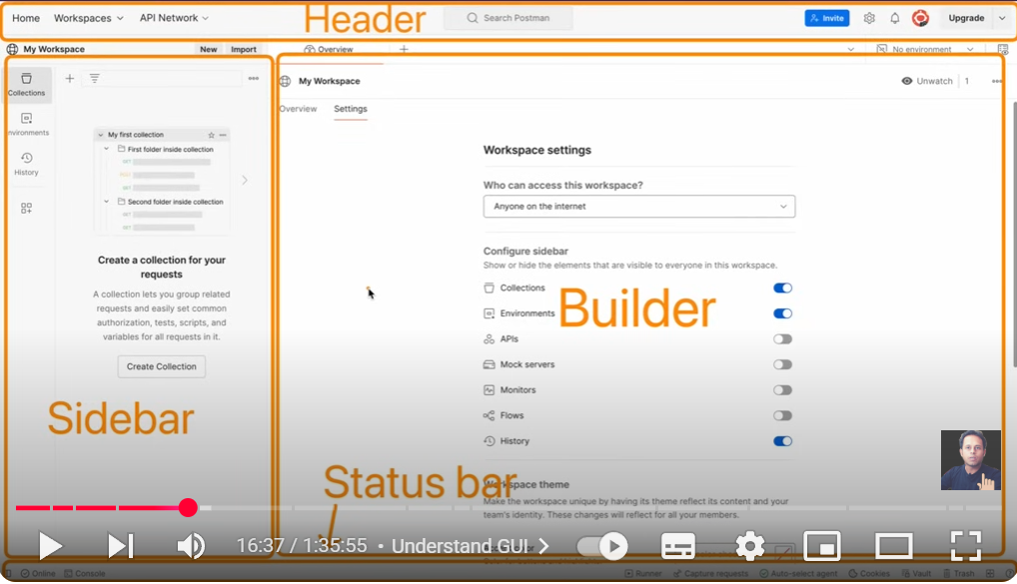
Understand GUI
How to add API Request
Run and check Response
Step1: Select the HTTP Method
Step2: Add the API endpoint
Step3: Add Headers, Authorizations etc. as needed
Step4: For POST,PUT requests add body
Step5: Save & Run, Check response
Sample API for Testing
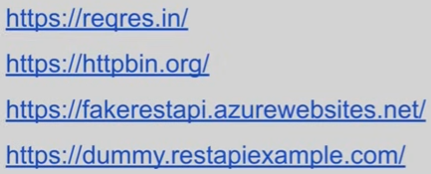

Authentication: Who you are?
Authorization: What you can do?
GET request
POST request
Payload – request body
Http status codes
https://developer.mozilla.org/en-US/docs/Web/HTTP/Reference/Status
PUT & PATCH request
DELETE request
Collections
Variables
Environment
Scripts
Tests
Collections
- What is collection?
  - It is a group of API requests
- How to create collection?
- How to create folders inside collection?
- How to arrange requests inside collection?
- How to bring your collection to the top
Variables:
- What are variables?
Elements that can store different values

- Why and when to use variables?
https://example.com/users
Key:URL
Value: https://example.com/users
Reuse the value at multiple locations.
If required, change can be done at a single place.
When?
Some value is repeatedly used at multiple places
Extract out all common values and keep them at one place

- How to create variables?
- How to refer variables?

Get and Set variables with scripts
- Set variables with scripts
Global: pm.globals.set(“name”,”edison”);
Collection: pm.collectionVariables.set(“name”,”edison”)
Environment: pm.environment.set(“name”,”karthik”)
Local: pm.variables.set(“name”,”karthik”)

Priority:
- Local
- Data
- Env
- Collection
- Global

